February 2-6, 2026
CS 800: Recursive Language Models
- Current codebase does not implement working with multiple depths. Even if we set max_depth=5, it has no effect. Code only runs within depth=1.
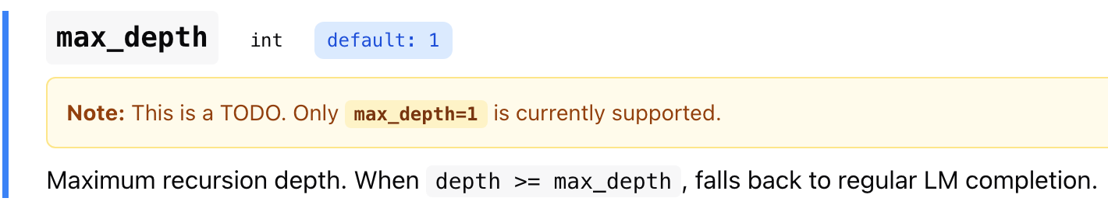
- Even if we implement more depths into the current repo, how would they run:
  - Parallel (like an agent council) OR
  - Sequentially (depth 2 is only invoked if depth 1 cannot find the answer)
- If their initial plan was to run them sequentially, what’s the advantage of calling multiple depths vs. single depth with more iterations:
  - Example: max_depth = 3, max_iterations = 30 vs. max depth = 1, max_iterations = 90
- We can combine RLMs with task decomposition like the github.com/sentient-agi/ROMA architecture. Our difference: context off-loading using RLMs. ROMA uses an external agent to decide if given task is “atomic” or not.
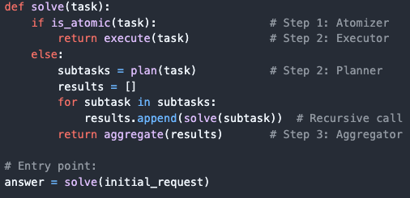

- Proposal:
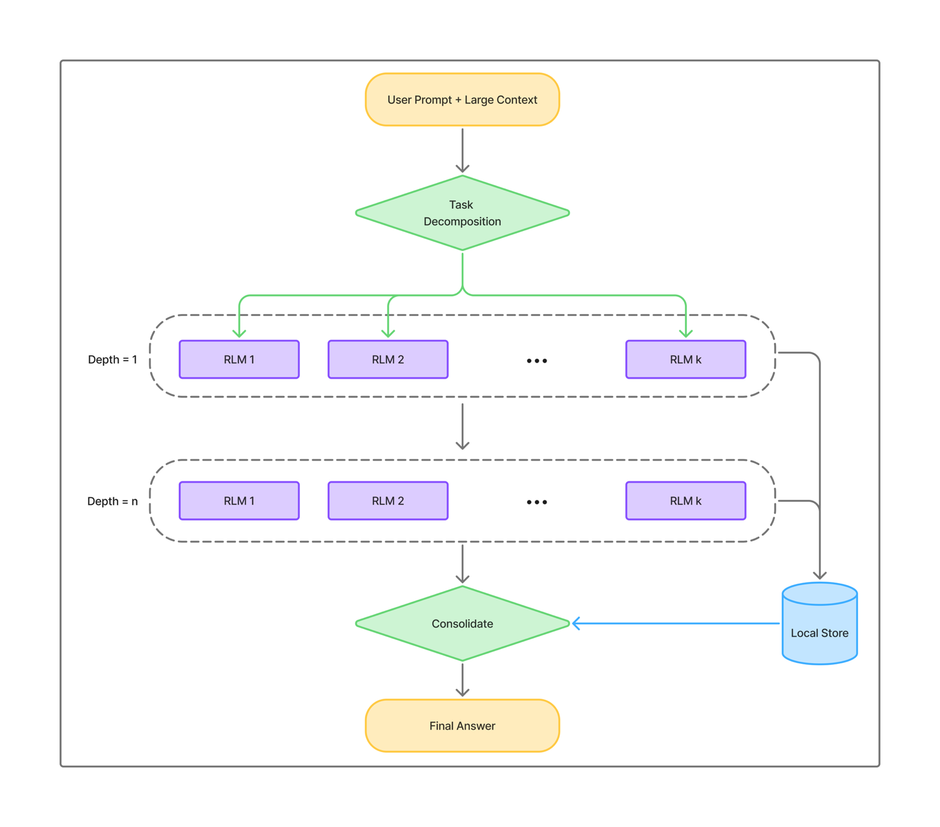
- What this improves/solves:
  - Handle even larger contexts (“RLMs can scale to the 10M+ token regime”)
  - Instead of trying to load the input at once, divide it into sub-RLMs. Limit the number of RLMs in each layer so that ‘depth’ acts as an early stopping mechanism. If you find the answer at level 1, stop.
  - Store results so that recursive calls are faster and cheaper
- LangChain’s DeepAgents: https://docs.langchain.com/oss/python/deepagents/long-term-memory. Use the Deep Agents SDK when you want to build agents that can:
  - Handle complex, multi-step tasks that require planning and decomposition
  - Manage large amounts of context through file system tools (e.g. summarizing web search results)
  - However, cannot handle large input context (e.g. if the input has 10M+ tokens)
  - Delegate work to specialized subagents for context isolation
  - Persist memory across conversations and threads
LAST WEEK
- Ollama client implemented
  - Tested with gpt-5-nano-2025-08-07
    - 400K input & 128K output tokens
    - ~120 seconds (quickstart.py)
  - Tested with qwen2.5:7b (Q4 quantization) using Ollama
    - Works locally (haven’t tested on HPC but runs on my machine)
    - 128K input & 8K output tokens
    - ~43 seconds (quickstart.py)

- Current limitations presented in the paper:
  - Caching: We did not optimize our implementation of RLMs for speed, meaning each recursive LM call is both blocking and does not take advantage of any kind of prefix caching.
Optimization of current study?
  - Depending on the partition strategy employed by the RLM’s root LM, the lack of asynchrony can cause each query to range from a few seconds to several minutes.
Optimization of current study?
  - While we can control the length / “thinking time” of an RLM by increasing the maximum number of iterations, we do not currently have strong guarantees about controlling either the total API cost or the total runtime of each call.
Optimization of current study?
  - Explicitly training models to be used as RLMs (e.g. as root or sub-LMs) could provide additional performance improvements – as we found in §3.1, current models are inefficient decision makers over their context.
  - Many LM-based agents (Guo et al., 2024; Anthropic, 2025) use multiple, well-placed LM calls to solve a problem, however many of these calls are placed based on human-engineered workflows. These techniques emphasize task decomposition through recursive LM calls but are unable to handle long context inputs beyond the length of the base LM. RLMs, on the other hand, are enabled by an extremely simple intuition (i.e., placing the prompt as part of the external environment) to symbolically manipulate arbitrarily long strings and to iteratively refine their recursion via execution feedback from the persistent REPL environment.
Even though it says agents are not good at long context handling they might still be superior to RLMs. We could test this.
  - Currently only “max_depth=1” is supported. That's why the diagram does not circle back for another RLM instantiation. What's the advantage of having depth >1 compared to increasing “max_iterations”? What’s the difference compared to ROMA? Limitations of systems like ROMA are mentioned in the paper: “By treating the prompt as an object in the external environment, this simple design of RLMs tackles a foundational limitation in the many prior approaches (Anthropic, 2025; Sentient, 2025; Schroeder et al., 2025; Sun et al., 2025), which focus on recursive decomposition of the tasks but cannot allow their input to scale beyond the context window of the underlying LLM.”

- Research Direction:
  - Can we extend the capabilities to handle multi-modal inputs?
Smaller models struggle with understanding different file types and longer contexts. We could try to build a multi-modal version and measure cost.
From previous emails:
  - Implement RLM Infrastructure with Caching - Build a working RLM system using LangChain and/or Redis to enable efficient caching and address speed limitations.
  - Explore Context Rot Measurement - Develop methods to quantitatively measure context rot in long conversations.
  - Optimize for Cost and Runtime Control - Create mechanisms to better control API costs and runtime per call.
  - Benchmark and Evaluate - Test the implementation on long-context tasks to understand when RLMs provide advantages over standard inference.

Some AI assisted brainstorming:
- Learned Recursive Decomposition Strategies: Current RLMs rely on the LLM's ability to programmatically manage context, but you could train models specifically on optimal decomposition strategies through RL. Research question: Can we learn task-specific or general-purpose decomposition policies that outperform ad-hoc programmatic approaches?
- Hybrid Memory Architectures: Combine RLMs with differentiable memory systems (like memory networks or RETRO). The recursive calls could write to and read from a persistent, trainable memory structure rather than just variables in a REPL, enabling learned retrieval patterns alongside programmatic control.
- Cross-Model Recursive Orchestration: Instead of just calling itself, allow the root LLM to orchestrate different specialized models in the recursive calls (e.g., a reasoning model calling a math-specialized model, vision model, etc.). Research optimal model routing strategies.
- Continual Learning with Recursive Context: Use RLMs for continual learning where the environment contains not just the current prompt but a growing knowledge base. Study how to efficiently update and query this expanding context without retraining.
Some additional suggestions:
- Distributed Recursive Execution: Scale RLMs across multiple machines where sub-calls execute in parallel across different nodes. Research scheduling, load balancing, and fault tolerance in distributed recursive inference.
- Adversarial Robustness in Recursive Systems: Study how malicious inputs in the environment variable could exploit recursive calls (e.g., prompt injection attacks that manipulate the REPL state). Develop defense mechanisms specific to recursive architectures.
- Theoretical Analysis of Recursive Complexity: Formalize the computational complexity classes that RLMs can solve compared to standard LLMs. Questions: What problems become tractable with bounded recursion depth? Can you prove optimality bounds for certain decomposition strategies?
- Recursive Verification and Self-Correction: Build systems where recursive calls are specifically designed for verification—each sub-call validates or refines previous outputs. This could create more reliable multi-step reasoning with built-in error correction.
- Minimal Recursion Depth Optimization: While RLMs can handle 10M+ tokens, they have high variance in cost due to variable recursive calls. Research optimal stopping criteria and depth limits that balance quality with computational cost.
- Compression-Aware Recursion: Integrate learned compression techniques where each recursive call not only processes but also compresses its output before returning to the parent call, creating a hierarchical compressed representation of massive contexts.

